CSIT314 Software Development Methodologies - Group Project

Sprint 1 - US2: Log out
Interior Design Platform - User Admin
All diagrams were drawn in draw.io. Open "US2 Log out.drawio" in this folder to edit them - each diagram is its own page in that file. The exported images are in the "diagrams" folder.

Assumptions
- The system is the Interior Design Platform from the project specification. Sprint 1 covers the User Admin's log in / log out and managing user profiles and user accounts (US1-US12).
- A user profile is a user group, e.g. User Admin, Interior Designer, Customer or Platform Manager. It has a name, a description, a list of permissions (what its users can do) and a status (Active or Suspended). Every user account belongs to exactly one user profile and gets that profile's permissions.
- We follow B-C-E: the actor only talks to the boundary (page), the boundary only talks to the controller, and the controller works with the entity classes. There is one controller per use case.
- The boundary checks all the input (required fields, lengths, formats, e.g. not suspending your own profile) and trims spaces, then passes an entity object on. The controller just calls the entity and returns the result. The entity checks for duplicates and the database state (e.g. name already used, only Active rows are changed), then saves.
- The logged-in user is kept in a session (started in US1). Logging out ends that session.
- Every admin page checks the session first. If there is no logged-in user, it sends the person to the login page. This is what stops someone using the Back button after a log out.
- Log out does not ask "Are you sure?" because logging out can't lose any data.

1. User story
Story ID | US2
User story | As a user admin, I want to log out so that other people cannot use my account.
Actor | User Admin
Priority | High
Story points (estimate) | 1
Acceptance criteria | 1. Given I am logged in, there is a "Log out" button in the header of every admin page.  2. Given I am logged in, when I click "Log out", then my session ends and I am taken to the login page with the message "You have logged out successfully".  3. Given I have logged out, when someone presses the browser's Back button or opens an admin page link, then they are sent to the login page and can't see any admin page.  4. Given I have logged out, when I log in again with my details, then it works as normal.
Tasks | T2.1 Write the use case description and draw the use case diagram  T2.2 Draw the B-C-E class diagram and the sequence diagram  T2.3 Draw the wireframes for the Log out button and the logged-out login page  T2.4 Write the unit tests first (TDD) for LogoutController.logout()  T2.5 Code LogoutController.logout() to end the session  T2.6 Add the Log out button to the shared admin page header and code LogoutPage  T2.7 Add a session check to every admin page so it redirects to the login page when nobody is logged in  T2.8 Run the test cases, fix bugs and push to the repo so the CI pipeline runs the unit tests

2. Use case diagram
The user story becomes one use case, UC2 Log out. The User Admin is the only actor.
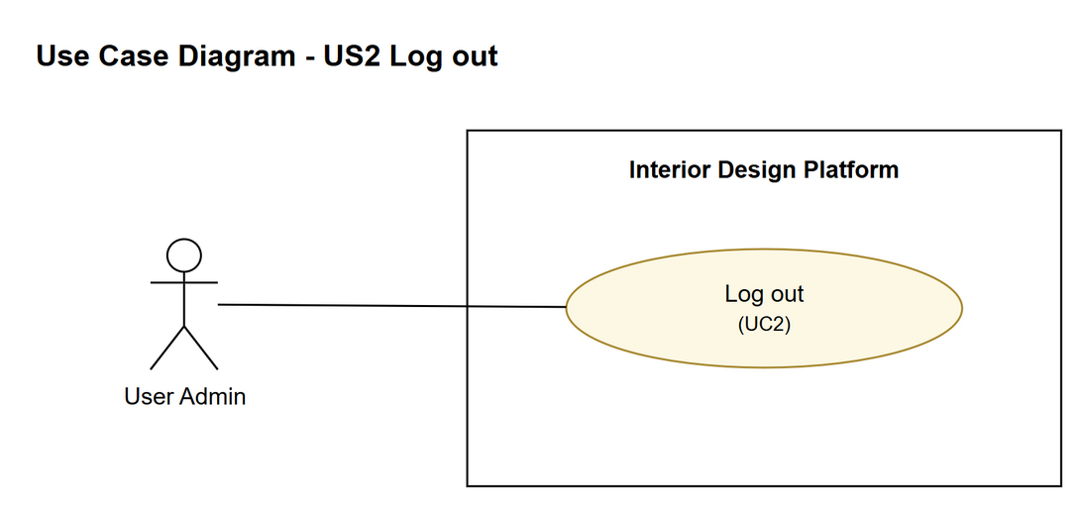
Figure 1: Use case diagram for US2 Log out

3. Use case description
Use case | UC2 Log out
Actor | User Admin
Brief description | The User Admin ends their session so nobody else can use the system with their account on this computer.
User story | US2: As a user admin, I want to log out so that other people cannot use my account.
Preconditions | The User Admin is logged in (UC1).
Trigger | The User Admin clicks "Log out" in the page header.
Basic flow | 1. The User Admin clicks "Log out".  2. The system ends the User Admin's session (the logged-in user is removed from the session).  3. The system shows the login page with the message "You have logged out successfully".
Alternative flows | 2a. The session had already ended (e.g. it timed out): the system shows the login page with the message "Your session has already ended".
Postconditions | The session is ended. Admin pages can't be opened (or reached with the Back button) until someone logs in again.

4. Wireframes
The wireframes were drawn in draw.io. They are low-fidelity: they show the layout and the flow, not the final colours. The orange numbers match the notes under each screen.

4a - Log out button on an admin page
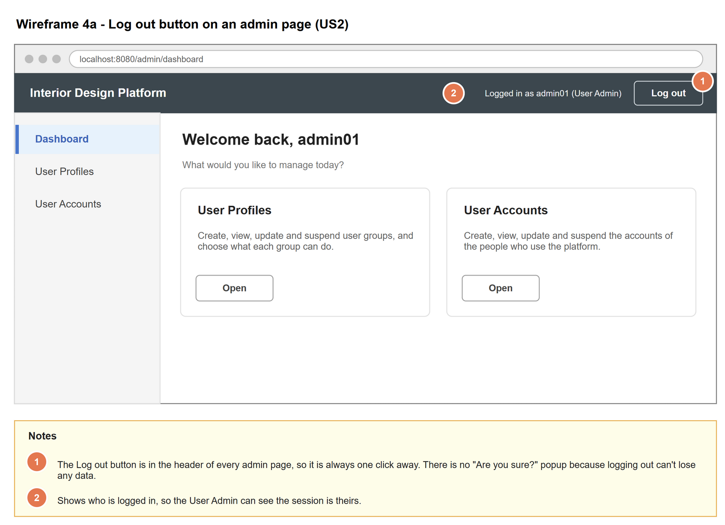
Figure 2: Wireframe 4a - Log out button on an admin page (US2)

4b - Back on the login page after logging out
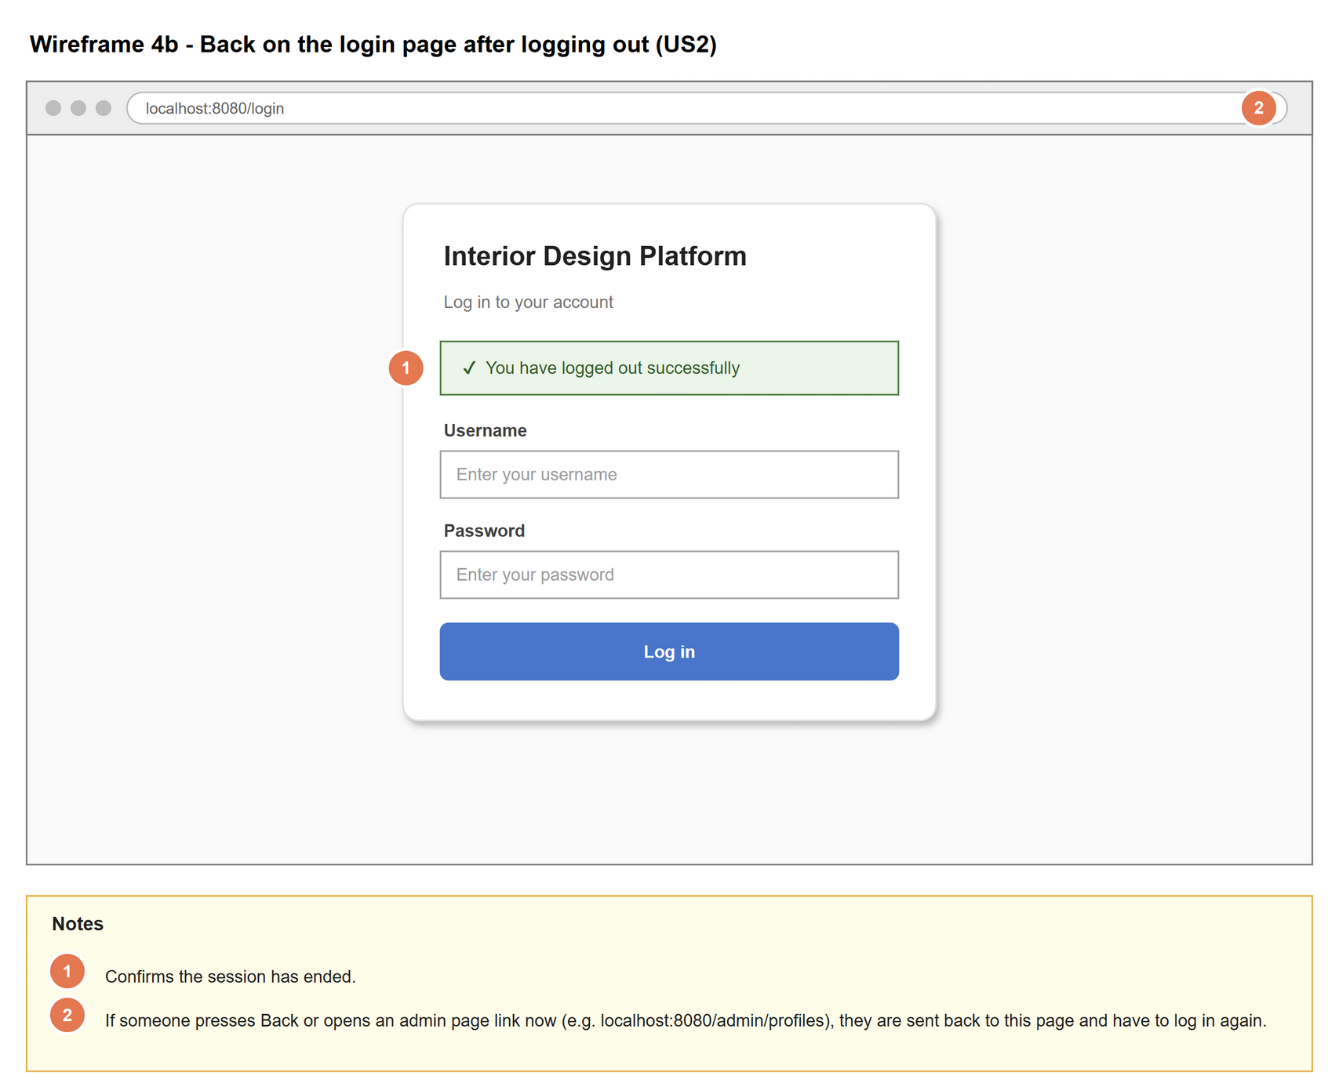
Figure 3: Wireframe 4b - Back on the login page after logging out (US2)

4c - Session had already ended
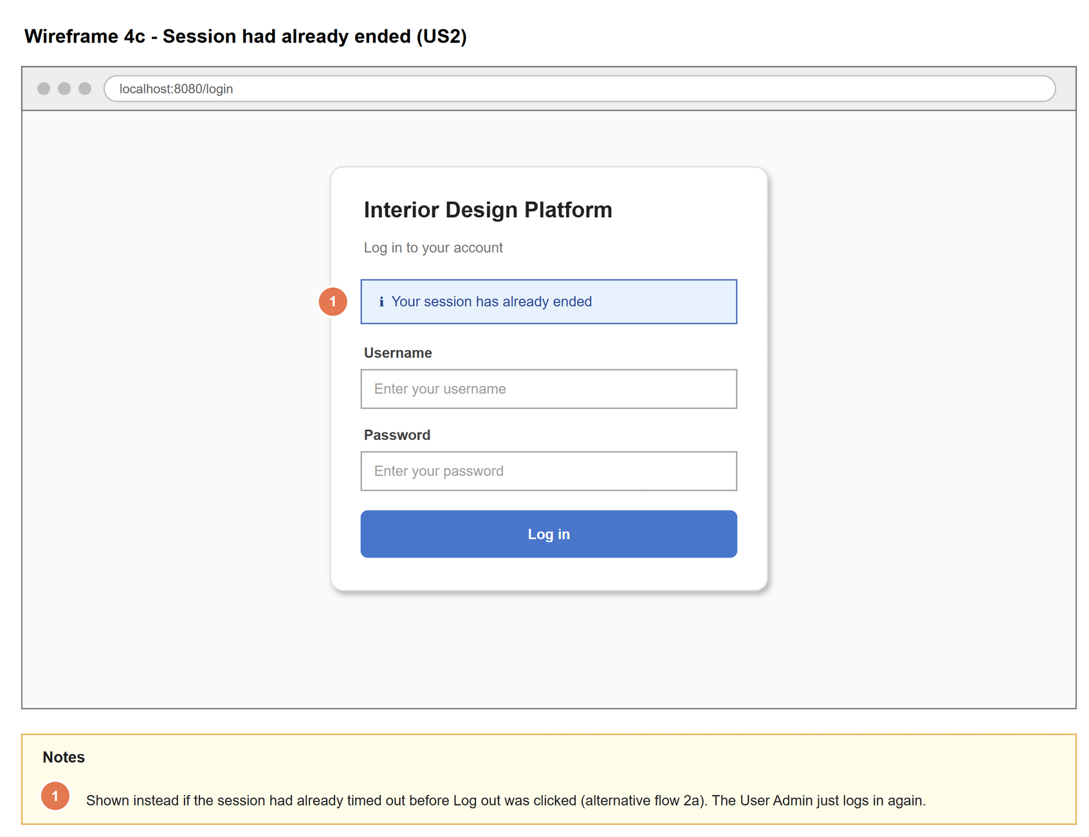
Figure 4: Wireframe 4c - Session had already ended (US2)

5. B-C-E class diagram
The solid arrow means the boundary calls the controller. There is no entity class, because log out does not read or change any saved data. Only the operations needed for this use case are shown.
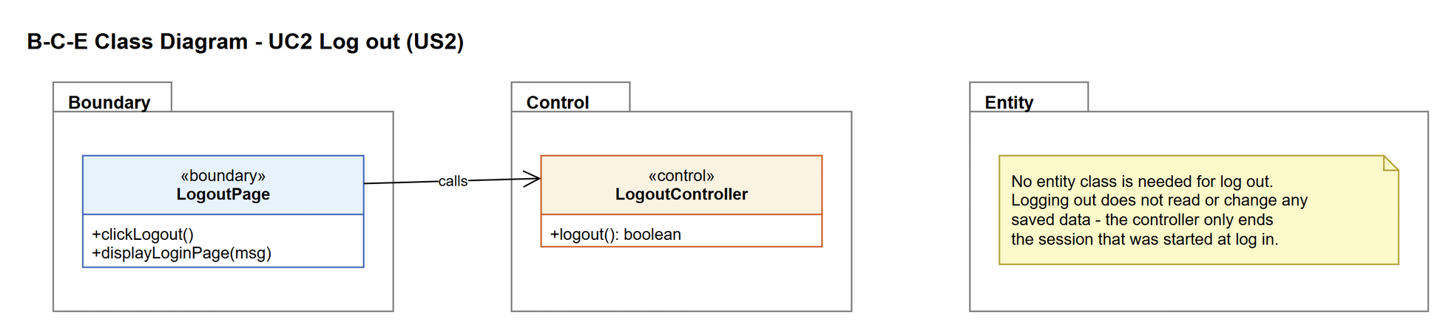
Figure 5: B-C-E class diagram for US2 Log out
Layer | Class | What it does
Boundary | LogoutPage | The Log out button in the header of every admin page. After the controller is done, it shows the login page with a message.
Control | LogoutController | Controller for UC2. Ends the current session. Returns True if a session was ended, or False if there was no session left to end.
Entity | (none) | Log out doesn't need any stored data, so no entity class is used.

6. Sequence diagram
The sequence diagram follows UC2. The page asks the controller to log out, and the controller ends the session. The alt box shows the basic flow (step 3) and alternative flow 2a (the session had already ended). Both branches end on the login page, just with a different message.
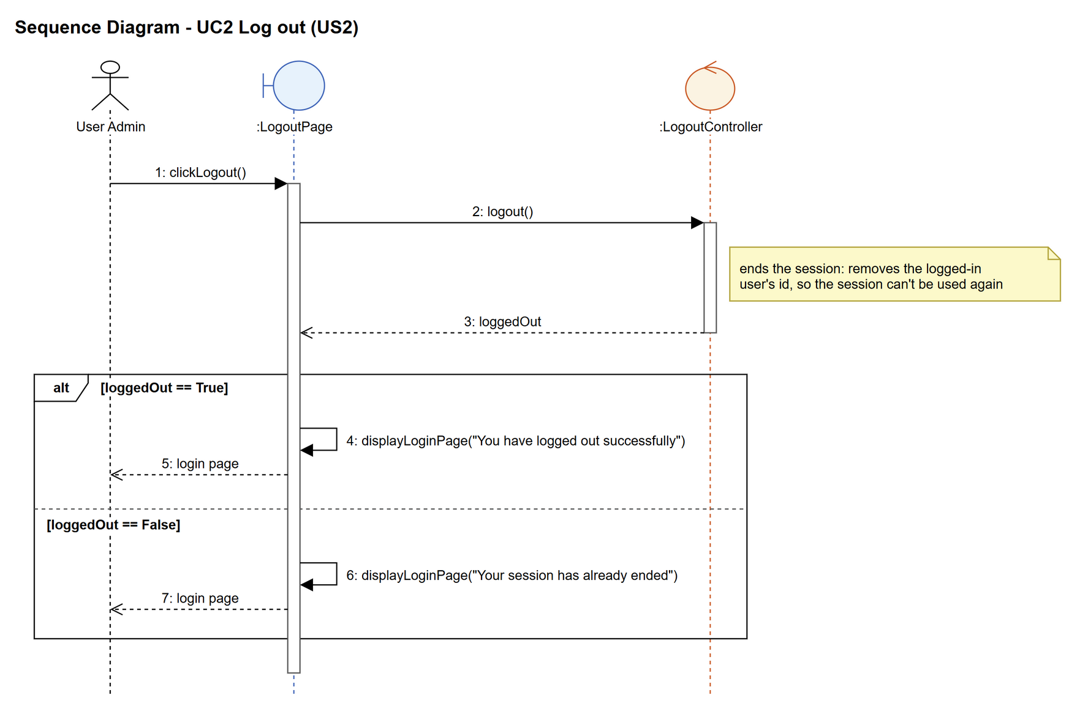
Figure 6: Sequence diagram for UC2 Log out

7. Test cases
Test data used below: user profiles User Admin (id 1), Interior Designer (id 2), Customer (id 3) and Platform Manager (id 4), all Active. User accounts admin01 / Admin@123 (User Admin, Active), admin02 / Admin@123 (User Admin, Suspended), designer1 / Pass@123 (Interior Designer, Active) and cust001 / Cust@123 (Customer, Active).

7a. System test cases (black box)
Equivalence partitioning and boundary value analysis were used to pick the test data. Fill in "Actual result" and "Pass/Fail" after running each test.
Test ID | Scenario | Prerequisites | Test steps | Test data | Expected result | Actual result | Pass / Fail
TC2.1 | Log out from the dashboard | Logged in as admin01, on the dashboard. | 1. Click "Log out" | - | The login page is shown with "You have logged out successfully".
TC2.2 | Log out from another admin page | Logged in as admin01, on the User Profiles page. | 1. Click "Log out" | - | Same result as TC2.1 (the button is on every admin page).
TC2.3 | Back button after logging out | TC2.1 has just been done. | 1. Press the browser's Back button | - | The login page is shown, not the dashboard. No admin data can be seen.
TC2.4 | Open an admin link after logging out | TC2.1 has just been done. | 1. Type the address of an admin page into the browser | localhost:5000/profiles | Redirected to the login page.
TC2.5 | Log in again after logging out | TC2.1 has just been done. | 1. Log in again | admin01 / Admin@123 | The dashboard opens as normal.
TC2.6 | Session had already ended | Logged in as admin01, then the session times out (or the session cookie is deleted). | 1. Click "Log out" | - | The login page is shown with "Your session has already ended". No error page.

7b. Unit test cases (for TDD)
These are written before the code (test-driven development) and run automatically in the CI pipeline. They cover normal inputs, abnormal inputs and boundary values.
Test ID | Class and method | Input / setup | Expected output | Type | Pass / Fail
UT2.1 | LogoutController.logout() | Session with admin01 logged in | Returns True. The session has no logged-in user afterwards. | Normal
UT2.2 | LogoutController.logout() | Session with nobody logged in | Returns False (no error thrown) | Abnormal
UT2.3 | LogoutController.logout() | Called twice in a row after logging in | First call returns True, second returns False | Abnormal

